2 Ways to Hack Windows 10 Password Easy Way

posted in[**Penetration Testing**](https://www.hackingarticles.in/category/penetration-testing/), [**Window Password Hacking**](https://www.hackingarticles.in/category/methods-of-windows-password-hacking/) on [**February 13, 2016**](https://www.hackingarticles.in/hack-windows-10-password-easy-way/) by [**Raj Chandel**](https://www.hackingarticles.in/author/raaz/)

SHARE

Save

Start your computer and enter into **Bios Setup**. Change your boot preferences to boot from **CD /DVD**. Click on Next

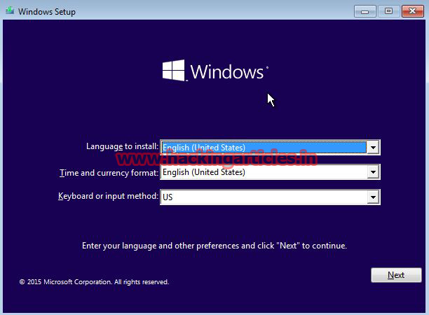

Now select the “**Repair your computer**” option from the lower left-hand corner.

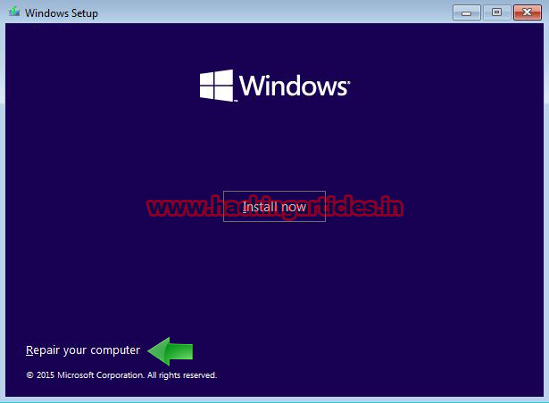

Then click on **Troubleshoot** option.

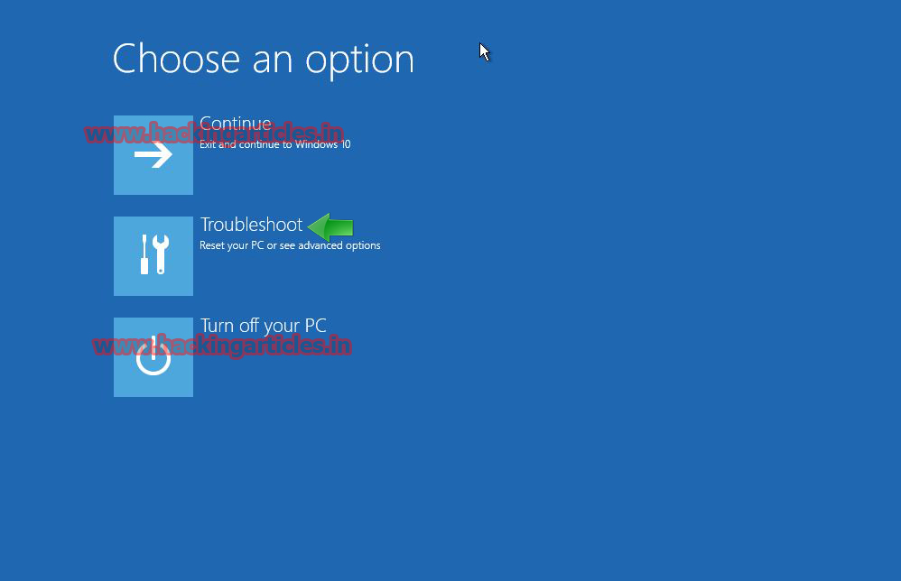

Then click on **advanced options**.

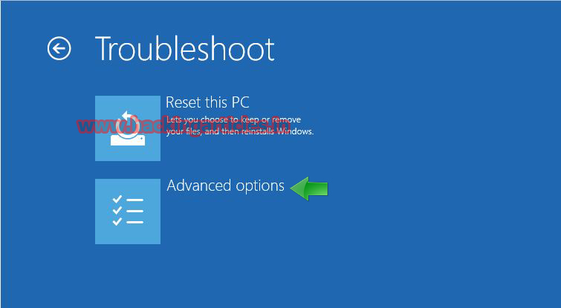

Now click on **command prompt**

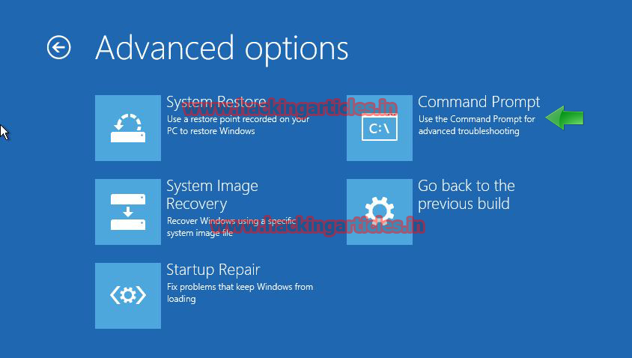

Then you’ll copy the command prompt executable (cmd.exe) over top of the **On Screen keyboard** executable



|  |  |
| --- | --- |
| 1 | copy d:\windows\system\32\cmd.exe d:\windows\system32\osk.exe |

Now you can reboot the PC.

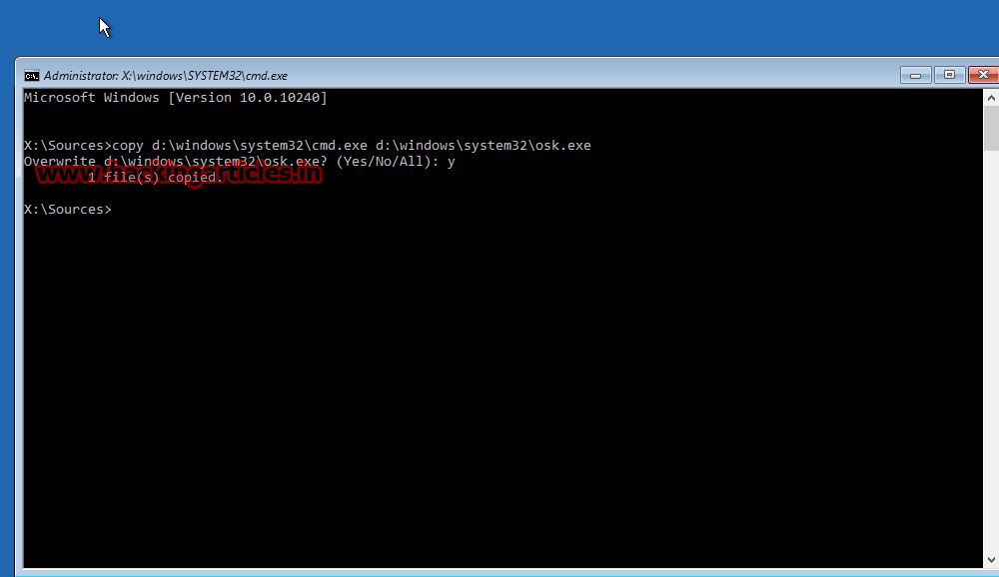

**Resetting the Password**

Once you get to the login screen, click on **On-Screen Keyboard,** and you’ll see an administrator mode command prompt.

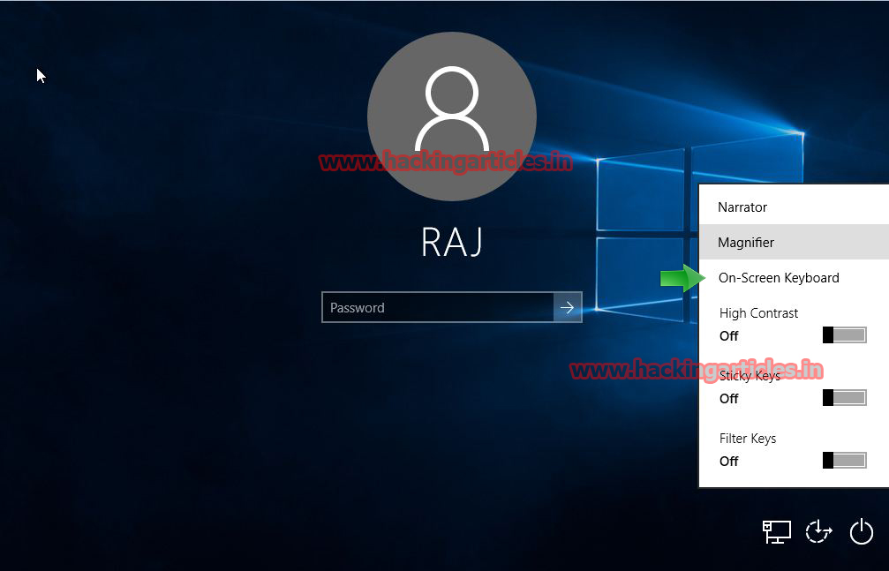

Now to reset the password—just type the following command, replacing the username and password with the combination you want:

**Syntax:** net user account.name *

**Example**: net user raj * and hit enter. Set any password for that account.

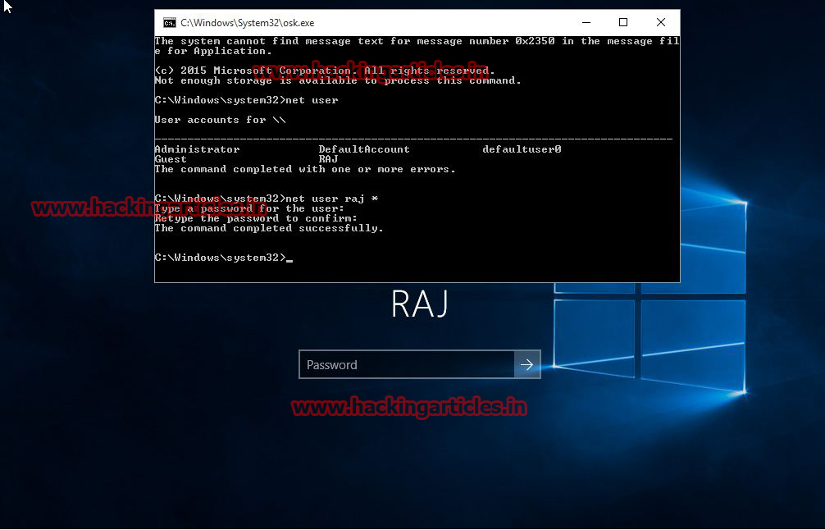

**Second Method**

Start your computer and enter into **Bios Setup**. Change your boot preferences to boot from **CD /DVD**. Click on Next

Press **SHIFT + F10** to open a command prompt

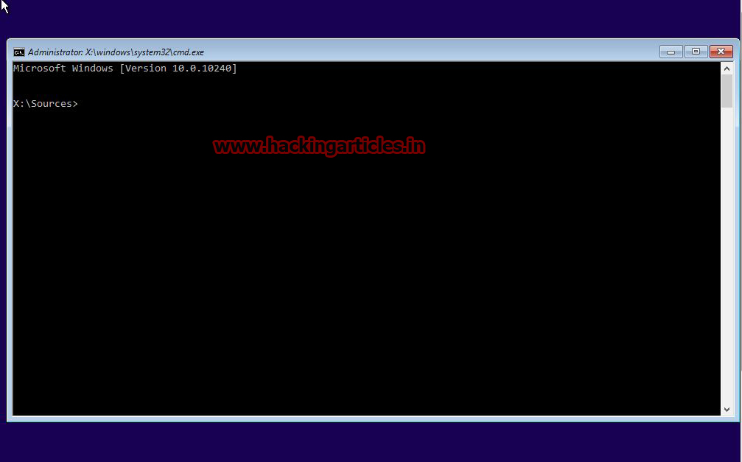

Then you’ll copy the command prompt executable (cmd.exe) over top of **utility manager** executable



|  |  |
| --- | --- |
| 1 | copy d:\windows\system32\cmd.exe d:\windows\system32\utilman.exe |

Now you can reboot the PC.

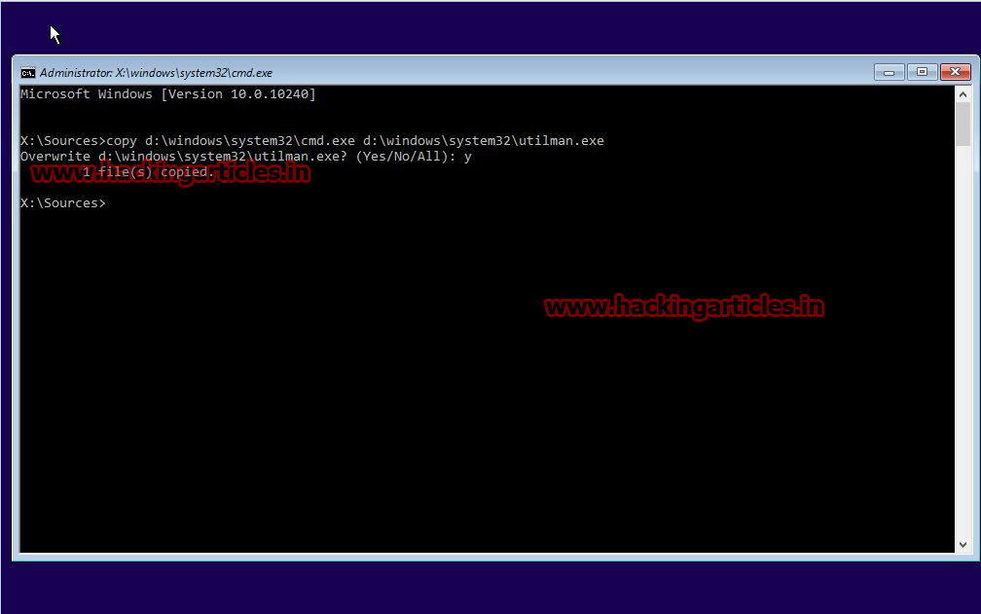

On the Windows 10 sign-in page, click the **Utility Manager** icon

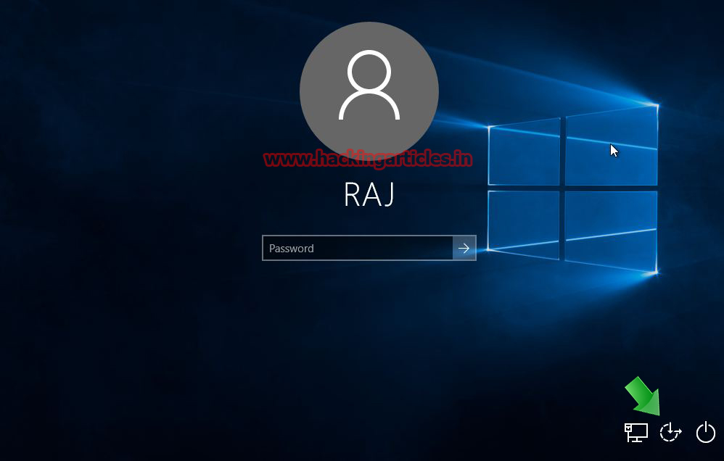

Now to reset the password—just type the following command, replacing the username and password with the combination you want:

**Syntax:** net user account.name *

**Example**: net user raj * and hit enter. Set any password for that account.

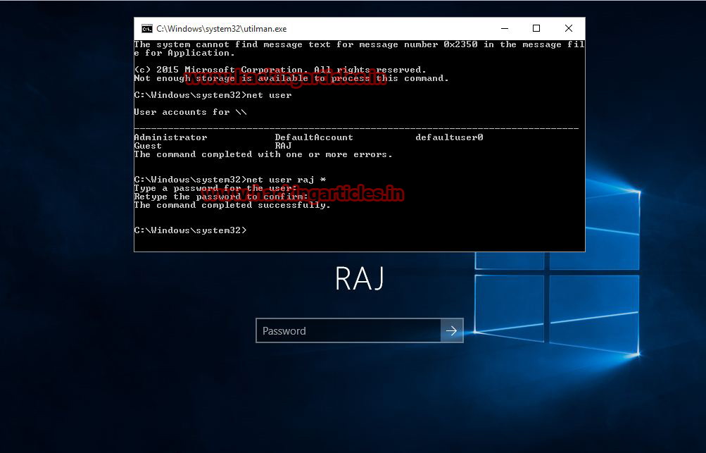

**3rd Way**

This method is the most user-friendly approach to hacking a Windows 10 password. It’s highly effective and doesn’t require any expertise to use. The simple three-step process will ensure that any Windows user or admin account is immediately accessible. The most reliable aspect of this utility, called TunesBro WinGeeker, is that it does not touch your data in any way.

**Step 1:** [Download TunesBro WinGeeker](https://www.tunesbro.com/windows-password-recovery.html) to a different PC, then use the built-in ISO burning utility to burn the ISO file and create a boot disk or boot drive. This is your password reset disk.

**Step 2:** When the disk or drive is ready, remove it and insert it into the locked PC. You will now need to go into the BIOS menu and change the boot priority so the system boots from your password reset disk instead of the Windows installation files that are on your hard drive.

**Step 3:** Once you see the TunesBro WinGeeker interface, you need to select the right Windows version and the user account that is locked. Click on ‘Reset Password’ to hack and blank the Windows 10 password. Now click on ‘Reboot’ and the job is done.

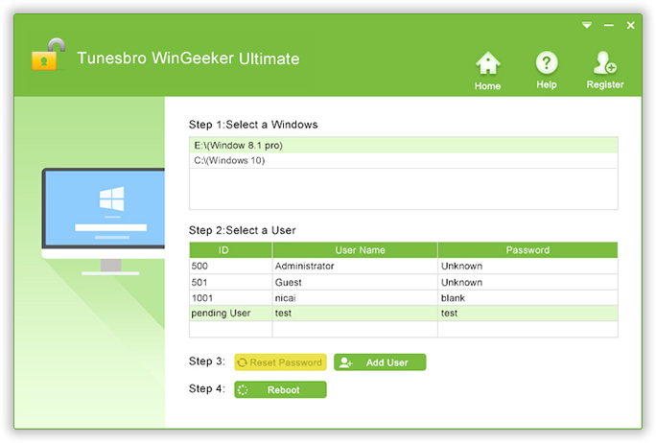

On restart, you will be able to access the account that was locked, and you won’t need to enter anything in the password field because it has just been blanked.

TunesBro WinGeeker works on multiple Windows versions and has been tested rigorously on more than four dozen PC, laptop and notebook brands from around the world. It has a 100% recovery rate and is used by millions of Windows users. It is a self-contained software application, which means you won’t need separate ISO burning software or be forced to do any command line work usually required to unlock a password. Simply create the password reset disk and use it to instantly remove any user, guest, admin, Server or Microsoft account password, and access your files without the fear of any data corruption or missing files.